Long-term biobanking: How long can you hold samples?

Posted by Richard Tsai on Apr 7, 2015 11:00:00 AM

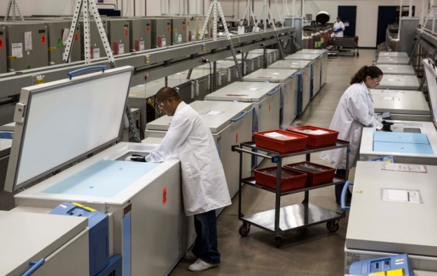
Biobanks are an essential component of medical research. However, in some cases researchers may retrieve samples from the biorepository only to find that the materials stored are no longer viable for testing. This may occur because the sample wasn't stored properly or because it spent too much time in storage before testing.
In order to prevent a loss of integrity among samples, all parties involved in the collection and storage of biospecimens must follow certain practices. For best results, these procedures should be based on up-to-date, relevant research studies that demonstrate the most effective methods for storing specimens, as well as the maximum length of time they can be stored safely. So what does our current research say?
Urine
According to Inside Biobanking, a recent study demonstrated that urine samples can be held for as long as 15 years without a complete loss of utility. This study, which was published in Clinical Biochemistry, evaluated 21 different parameters shortly after sample collection, at 12 years and at 15 years. More than half of the parameters measured after 12 or 15 years were not significantly different from their original values. Only mild differences were noted for 15 of the 21 parameters. The remaining parameters did show significant differences, although recovery rates never fell below 70 percent. In this study, samples were stored without preservatives at temperatures of -22°C.
Based on the results of this study, researchers can conclude that urine can be analyzed after at least 15 years of proper storage, depending on which parameters will be evaluated.
Hair
Hair samples can be used as a source of DNA, as well as in the fields of toxicology and forensic toxicology. However, the quality of hair samples degrade over time. For short-term storage, hair samples can be stored at room temperature. For long-term storage, hair samples should be stored at -20°C. Freezing hair samples at this low temperature can greatly extend their viability. In fact, a study published in Cancer Detection and Prevention successfully performed whole genome amplification on hair samples that had been stored for between 7 and 11 years. This study also found that hair samples containing the root were more reliable for DNA collection purposes.
Antibodies
Antibodies are compounds produced by the immune system in order to fight infection and neutralize foreign materials found in the body. Collecting and analyzing antibodies can provide researchers with a wealth of information that they can use to enhance their understanding of diseases and the human immune system. However, antibodies are fragile and must be handled carefully.
According to research published by Mary Johnson of Synatom Research, the maximum storage time for antibodies is highly dependent on the storage environment and the nature of the antibody itself. A study published in Histopathology found that, when stored at temperatures of 4°C, most antibodies will remain intact for anywhere from 12 to 26 years and can be used for routine histology research. Antibodies may also remain intact for many years when stored in liquid nitrogen or at temperatures below -20°C.
DNA
Multiple studies have demonstrated the robustness of the DNA molecule. With a half-life of 521 years, this molecule can persist for thousands of years if it is stored and handled appropriately. In fact, in 2009, the Discovery Channel reported that scientists had unearthed DNA estimated to be 419 million years old preserved within ancient salt deposits.
In light of this evidence, it seems DNA could be stored for long periods of time without losing its integrity. According to Oxford Gene Technology, DNA can be successfully stored for the longest period of time if it is dried or kept at temperatures below -164 degrees Celsius. In these conditions, DNA may remain usable for decades. DNA can also be stored for lengthy periods as a precipitate under ethanol at temperatures of -80 degrees Celsius or below.
When it comes to long-term biobanking, understanding your sample's limitations is essential. By using the information above as a guide to determine the best practices for storing your samples, you can maximize their shelf life and ensure that they are viable when you need them.

